National University of Computer and Emerging Sciences



Lab Manual 08

Data Structures Lab

|  |  |
| --- | --- |
| Course Instructor | Dr. Zareen Alamgir |
| Lab Instructor (s) | Fariha Maqbool  Humna Shabir |
| Section | F |
| Semester | Fall 2022 |

Department of Computer Science

FAST-NU, Lahore, Pakistan

## Objectives

After performing this lab, students shall be able to:

* Learn and practice BSTs.

Implement Binary Search Tree and create the functions described below:

**Task 1:**

Implement the following functions on an BST

* Add a method called **pathSums** which return an array containing the sums of the keys along each path of the tree, starting from the root to each leaf.

For example, for the tree given below, the method should return an array containing

[18, 20, 76, 126].

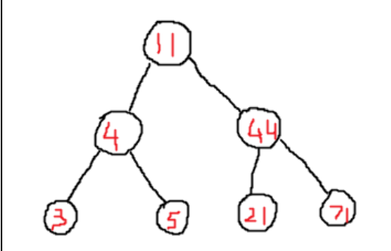

* Add the **operator ==** function. When it is used like bst1==bst2, it should return true if bst1 and bst2 have the exact same data, even though their structures may be different.
* A function **findancestor** that returns the ancestor of the node passed as argument

For example, for the above tree if the value passed is 4 then its ancestor is 11.

* Add a recursive method called **trimBelowK**. It should accept a number k>=0. The method should delete all nodes in the levels below level k, i.e. all nodes in levels k+1, k+2, and so on. Make sure that the new leaf nodes now have NULL children. No new nodes may be allocated at any stage. This method should take no more than O(n) time.
* Write a method called **lowestCommonAncestor**. This method should return the key that is the lowest (nearest) common ancestor of two keys passed in parameters. For example, in the following bst, the lowest common ancestor of 81 and 55 is 70; the lowest common ancestor of 55 and 63 is 61; while the lowest common ancestor of 2 and 63 is 50, etc. If one of the keys is an ancestor of the other than that key should be reported. For example, the lowest common ancestor of 70 and 91 is 70, etc.

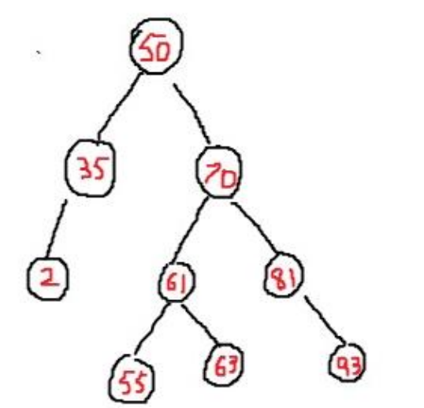

* Create a main function to test the above functionality